Automated Detection of Digitally Replicated Signatures
in Large-Scale Financial Audit Reports
[Authors removed for double-blind review]
[Affiliations removed for double-blind review]

Abstract
Regulations in many jurisdictions require Certified Public Accountants (CPAs) to personally sign each audit report they certify. However, the digitization of financial reporting makes it trivial to reuse a scanned signature image across multiple reports, bypassing this requirement. Unlike signature forgery, where an impostor imitates another person's handwriting, signature replication involves a legitimate signer reusing a digital copy of their own genuine signature—a practice that is virtually undetectable through manual inspection at scale. We present an end-to-end AI pipeline that automatically detects signature replication in financial audit reports. The pipeline employs a Vision-Language Model for signature page identification, YOLOv11 for signature region detection, and ResNet-50 for deep feature extraction, followed by a dual-method verification combining cosine similarity with perceptual hashing (pHash). This dual-method design distinguishes consistent handwriting style (high feature similarity but divergent perceptual hashes) from digital replication (convergent evidence across both methods), resolving an ambiguity that single-metric approaches cannot address. We apply this pipeline to 90,282 audit reports filed by publicly listed companies in Taiwan over a decade (2013–2023), analyzing 182,328 signatures from 758 CPAs. Using a known-replication accounting firm as a calibration reference, we establish distribution-free detection thresholds validated against empirical ground truth. Our analysis reveals that cosine similarity alone overestimates replication rates by approximately 25-fold, underscoring the necessity of multi-method verification. To our knowledge, this is the largest-scale forensic analysis of signature authenticity in financial documents.

Impact Statement
Auditor signatures on financial reports are a key safeguard of corporate accountability. When Certified Public Accountants digitally copy and paste a single signature image across multiple reports instead of signing each one individually, this safeguard is undermined—yet detecting such practices through manual inspection is infeasible at the scale of modern financial markets. We developed an artificial intelligence system that automatically extracts and analyzes signatures from over 90,000 audit reports spanning ten years of filings by publicly listed companies. By combining deep learning-based visual feature analysis with perceptual hashing, the system distinguishes genuinely handwritten signatures from digitally replicated ones. Our analysis reveals that signature replication practices vary substantially across accounting firms, with measurable differences between firms known to use digital replication and those that do not. This technology can be directly deployed by financial regulators to automate signature authenticity monitoring at national scale.

I. Introduction
Financial audit reports serve as a critical mechanism for ensuring corporate accountability and investor protection. In Taiwan, the Certified Public Accountant Act (會計師法 §4) and the Financial Supervisory Commission’s attestation regulations (查核簽證核準準則 §6) require that certifying CPAs affix their signature or seal (簽名或蓋章) to each audit report [1]. While the law permits either a handwritten signature or a seal, the CPA’s attestation on each report is intended to represent a deliberate, individual act of professional endorsement for that specific audit engagement [2].
The digitization of financial reporting, however, has introduced a practice that challenges this intent. As audit reports are now routinely generated, transmitted, and archived as PDF documents, it is technically trivial for a CPA to digitally replicate a single scanned signature image and paste it across multiple reports. Although this practice may not violate the literal statutory requirement of “signature or seal,” it raises substantive concerns about audit quality: if a CPA’s signature is applied identically across hundreds of reports without any variation, does it still represent meaningful attestation of individual professional judgment? Unlike traditional signature forgery, where a third party attempts to imitate another person’s handwriting, signature replication involves the legitimate signer reusing a digital copy of their own genuine signature. This practice, while potentially widespread, is virtually undetectable through manual inspection at scale: regulatory agencies overseeing thousands of publicly listed companies cannot feasibly examine each signature for evidence of digital duplication.
The distinction between signature replication and signature forgery is both conceptually and technically important. The extensive body of research on offline signature verification [3]–[8] has focused almost exclusively on forgery detection—determining whether a questioned signature was produced by its purported author or by an impostor. This framing presupposes that the central threat is identity fraud. In our context, identity is not in question; the CPA is indeed the legitimate signer. The question is whether the physical act of signing occurred for each individual report, or whether a single signing event was digitally propagated across many reports. This replication detection problem is, in one sense, simpler than forgery detection—we need not model the variability of skilled forgers—but it requires a different analytical framework, one focused on detecting abnormally high similarity across documents rather than distinguishing genuine from forged specimens.
Despite the significance of this problem for audit quality and regulatory oversight, no prior work has addressed signature replication detection in financial documents at scale. Woodruff et al. [9] developed an automated pipeline for signature analysis in corporate filings for anti-money laundering investigations, but their work focused on author clustering (grouping signatures by signer identity) rather than detecting reuse of digital copies. Copy-move forgery detection methods [10], [11] address duplicated regions within or across images, but are designed for natural images and do not account for the specific characteristics of scanned document signatures, where legitimate visual similarity between a signer’s authentic signatures is expected and must be distinguished from digital duplication. Research on near-duplicate image detection using perceptual hashing combined with deep learning [12], [13] provides relevant methodological foundations, but has not been applied to document forensics or signature analysis.
In this paper, we present a fully automated, end-to-end pipeline for detecting digitally replicated CPA signatures in audit reports at scale. Our approach processes raw PDF documents through six sequential stages: (1) signature page identification using a Vision-Language Model (VLM), (2) signature region detection using a trained YOLOv11 object detector, (3) deep feature extraction via a pre-trained ResNet-50 convolutional neural network, (4) dual-method similarity verification combining cosine similarity of deep features with perceptual hash (pHash) distance, (5) distribution-free threshold calibration using a known-replication reference group, and (6) statistical classification with cross-method validation.
The dual-method verification is central to our contribution. Cosine similarity of deep feature embeddings captures high-level visual style similarity—it can identify signatures that share similar stroke patterns and spatial layouts—but cannot distinguish between a CPA who signs consistently and one who reuses a digital copy. Perceptual hashing, by contrast, captures structural-level similarity that is sensitive to pixel-level correspondence. By requiring convergent evidence from both methods, we can differentiate style consistency (high cosine similarity but divergent pHash) from digital replication (high cosine similarity with convergent pHash), resolving an ambiguity that neither method can address alone.
A distinctive feature of our approach is the use of a known-replication calibration group for threshold validation. Through domain expertise, we identified a major accounting firm (hereafter “Firm A”) whose signatures are known to be digitally replicated across all audit reports. This provides an empirical anchor for calibrating detection thresholds: any threshold that fails to classify Firm A’s signatures as replicated is demonstrably too conservative, while the distributional characteristics of Firm A’s signatures establish an upper bound on the similarity values achievable through replication in real-world scanned documents. This calibration strategy—using a known-positive subpopulation to validate detection thresholds—addresses a persistent challenge in document forensics, where ground truth labels are scarce.
We apply this pipeline to 90,282 audit reports filed by publicly listed companies in Taiwan between 2013 and 2023, extracting and analyzing 182,328 individual CPA signatures from 758 unique accountants. To our knowledge, this represents the largest-scale forensic analysis of signature authenticity in financial documents reported in the literature.
The contributions of this paper are summarized as follows:
- Problem formulation: We formally define the signature replication detection problem as distinct from signature forgery detection, and argue that it requires a different analytical framework focused on intra-signer similarity distributions rather than genuine-versus-forged classification.
- End-to-end pipeline: We present a fully automated pipeline that processes raw PDF audit reports through VLM-based page identification, YOLO-based signature detection, deep feature extraction, and dual-method similarity verification, requiring no manual intervention after initial model training.
- Dual-method verification: We demonstrate that combining deep feature cosine similarity with perceptual hashing resolves the fundamental ambiguity between style consistency and digital replication, supported by an ablation study comparing three feature extraction backbones.
- Calibration methodology: We introduce a threshold calibration approach using a known-replication reference group, providing empirical validation in a domain where labeled ground truth is scarce.
- Large-scale empirical analysis: We report findings from the analysis of over 90,000 audit reports spanning a decade, providing the first large-scale empirical evidence on signature replication practices in financial reporting.
The remainder of this paper is organized as follows. Section II reviews related work on signature verification, document forensics, and perceptual hashing. Section III describes the proposed methodology. Section IV presents experimental results including the ablation study and calibration group analysis. Section V discusses the implications and limitations of our findings. Section VI concludes with directions for future work.

II. Related Work

A. Offline Signature Verification
Offline signature verification—determining whether a static signature image is genuine or forged—has been studied extensively using deep learning. Bromley et al. [3] introduced the Siamese neural network architecture for signature verification, establishing the pairwise comparison paradigm that remains dominant. Dey et al. [4] proposed SigNet, a convolutional Siamese network for writer-independent offline verification, demonstrating that deep features learned from signature images generalize across signers without per-writer retraining. Hadjadj et al. [5] addressed the practical constraint of limited reference samples, achieving competitive verification accuracy using only a single known genuine signature per writer. More recently, Li et al. [6] introduced TransOSV, the first Vision Transformer-based approach for offline signature verification, achieving state-of-the-art results. Tehsin et al. [7] evaluated distance metrics for triplet Siamese networks, finding that Manhattan distance outperformed cosine and Euclidean alternatives.
A common thread in this literature is the assumption that the primary threat is identity fraud: a forger attempting to produce a convincing imitation of another person’s signature. Our work addresses a fundamentally different problem—detecting whether the legitimate signer reused a digital copy of their own signature—which requires analyzing intra-signer similarity distributions rather than modeling inter-signer discriminability.
Brimoh and Olisah [8] proposed a consensus-threshold approach that derives classification boundaries from known genuine reference pairs, the methodology most closely related to our calibration strategy. However, their method operates on standard verification benchmarks with laboratory-collected signatures, whereas our approach applies threshold calibration using a known-replication subpopulation identified through domain expertise in real-world regulatory documents.

B. Document Forensics and Copy Detection
Copy-move forgery detection (CMFD) identifies duplicated regions within or across images, typically targeting manipulated photographs [10]. Abramova and Bohme [11] adapted block-based CMFD to scanned text documents, noting that standard methods perform poorly in this domain because legitimate character repetitions produce high similarity scores that confound duplicate detection.
Woodruff et al. [9] developed the work most closely related to ours: a fully automated pipeline for extracting and analyzing signatures from corporate filings in the context of anti-money laundering investigations. Their system uses connected component analysis for signature detection, GANs for noise removal, and Siamese networks for author clustering. While their pipeline shares our goal of large-scale automated signature analysis on real regulatory documents, their objective—grouping signatures by authorship—differs fundamentally from ours, which is detecting digital replication within a single author’s signatures across documents.
In the domain of image copy detection, Pizzi et al. [13] proposed SSCD, a self-supervised descriptor using ResNet-50 with contrastive learning for large-scale copy detection on natural images. Their work demonstrates that pre-trained CNN features with cosine similarity provide a strong baseline for identifying near-duplicate images, supporting our feature extraction approach.

C. Perceptual Hashing
Perceptual hashing algorithms generate compact fingerprints that are robust to minor image transformations while remaining sensitive to substantive content changes [14]. Jakhar and Borah [12] demonstrated that combining perceptual hashing with deep learning features significantly outperforms either approach alone for near-duplicate image detection, achieving AUROC of 0.99. Their two-stage architecture—pHash for fast structural comparison followed by deep features for semantic verification—provides methodological precedent for our dual-method approach, though applied to natural images rather than document signatures.

D. Deep Feature Extraction for Signature Analysis
Several studies have explored pre-trained CNN features for signature comparison without metric learning or Siamese architectures. Engin et al. [15] used ResNet-50 features with cosine similarity for offline signature verification on real-world scanned documents, incorporating CycleGAN-based stamp removal as preprocessing. Tsourounis et al. [16] demonstrated successful transfer from handwritten text recognition to signature verification. Chamakh and Bounouh [17] confirmed that a simple ResNet backbone with cosine similarity achieves competitive verification accuracy across multilingual signature datasets without fine-tuning, supporting the viability of our off-the-shelf feature extraction approach.

III. Methodology

A. Pipeline Overview
We propose a six-stage pipeline for large-scale signature replication detection in scanned financial documents. Fig. 1 illustrates the overall architecture. The pipeline takes as input a corpus of PDF audit reports and produces, for each document, a classification of its CPA signatures as genuine, uncertain, or replicated, along with confidence scores and supporting evidence from multiple verification methods.
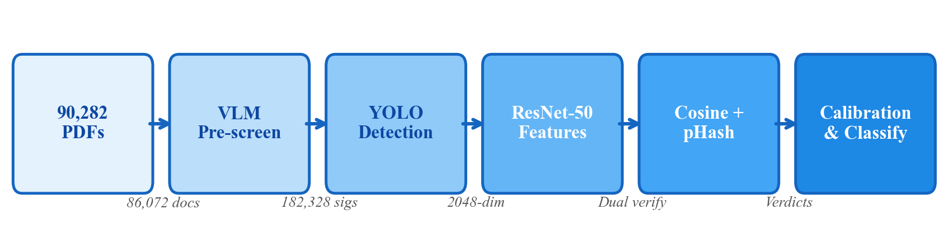
Fig. 1. Pipeline architecture for automated signature replication detection.

B. Data Collection
The dataset comprises 90,282 annual financial audit reports filed by publicly listed companies in Taiwan, covering fiscal years 2013 to 2023. The reports were collected from the Market Observation Post System (MOPS) operated by the Taiwan Stock Exchange Corporation, the official repository for mandatory corporate filings. CPA names, affiliated accounting firms, and audit engagement tenure were obtained from a publicly available audit firm tenure registry encompassing 758 unique CPAs.
TABLE I: Dataset Summary
Attribute | Value
Total PDF documents | 90,282
Date range | 2013–2023
Documents with signatures | 86,072 (95.4%)
Unique CPAs identified | 758
Accounting firms | >50

C. Signature Page Identification
To identify which page of each multi-page PDF contains the auditor’s signatures, we employed the Qwen2.5-VL vision-language model (32B parameters) [18] as an automated pre-screening mechanism. Each PDF page was rendered to JPEG at 180 DPI and submitted to the VLM with a structured prompt requesting a binary determination of whether the page contains a Chinese handwritten signature. The scanning range was restricted to the first quartile of each document’s page count, reflecting the regulatory structure of Taiwanese audit reports. This process identified 86,072 documents with signature pages. Cross-validation between the VLM and subsequent YOLO detection confirmed high agreement: YOLO successfully detected signature regions in 98.8% of VLM-positive documents.

D. Signature Detection
We adopted YOLOv11n (nano variant) [19] for signature region localization. A training set of 500 randomly sampled signature pages was annotated using a custom web-based interface following a two-stage protocol: primary annotation followed by independent review and correction.
TABLE II: YOLO Detection Performance
Metric | Value
Precision | 0.97–0.98
Recall | 0.95–0.98
mAP@0.50 | 0.98–0.99
mAP@0.50:0.95 | 0.85–0.90

Batch inference on 86,071 documents extracted 182,328 signature images at 43.1 documents/second (8 workers). A red stamp removal step was applied using HSV color space filtering. Each signature was matched to its corresponding CPA using positional order against the official registry, achieving a 92.6% match rate.

E. Feature Extraction
Each extracted signature was encoded into a 2048-dimensional feature vector using a pre-trained ResNet-50 CNN [20] with ImageNet-1K V2 weights, used as a fixed feature extractor without fine-tuning. Preprocessing consisted of resizing to 224×224 pixels with aspect ratio preservation and white padding, followed by ImageNet channel normalization. All feature vectors were L2-normalized, ensuring that cosine similarity equals the dot product. The choice of ResNet-50 without fine-tuning was motivated by three considerations: (1) the task is similarity comparison rather than classification; (2) ImageNet features transfer effectively to document analysis [15], [16]; and (3) the absence of fine-tuning preserves generalizability. This design choice is validated by an ablation study (Section IV-F).

F. Dual-Method Similarity Verification
For each signature, the most similar signature from the same CPA across all other documents was identified via cosine similarity. Two complementary measures were then computed against this closest match:
Cosine similarity captures high-level visual style similarity: sim(fA, fB) = fA · fB, where fA and fB are L2-normalized feature vectors. A high cosine similarity indicates shared visual characteristics but does not distinguish between consistent handwriting style and digital duplication.
Perceptual hash (pHash) distance captures structural-level similarity. Each signature is converted to a 64-bit binary fingerprint by resizing to 9×8 pixels and computing horizontal gradient differences. The Hamming distance between two hashes quantifies perceptual dissimilarity: 0 indicates perceptually identical images, while distances exceeding 15 indicate clearly different images.
The complementarity of these measures resolves the style-versus-replication ambiguity: high cosine + low pHash = converging evidence of replication; high cosine + high pHash = consistent style, not replication. SSIM was excluded as a primary method because scan-induced pixel variations caused a known-replication firm to exhibit a mean SSIM of only 0.70.

G. Threshold Selection and Calibration
Intra-class (same CPA, 41.3M pairs) and inter-class (different CPAs, 500K pairs) cosine similarity distributions were computed. Shapiro-Wilk tests rejected normality (p < 0.001), motivating distribution-free, percentile-based thresholds. The primary threshold was derived via KDE crossover—the point where intra- and inter-class density functions intersect.
A distinctive aspect is the use of Firm A—a major firm whose signatures are known to be digitally replicated—as a calibration reference. Firm A’s distribution provides: (1) lower bound validation—any threshold must classify the vast majority of Firm A as replicated; and (2) upper bound estimation—Firm A’s 1st percentile establishes the floor of similarity achievable through replication in scanned documents.

H. Classification
The final per-document classification integrates evidence from both methods: (1) Definite replication: pixel-identical match or SSIM > 0.95 with pHash ≤ 5; (2) Likely replication: cosine > 0.95 with pHash ≤ 5, or multiple methods indicate replication; (3) Uncertain: cosine between KDE crossover and 0.95 without structural evidence; (4) Likely genuine: cosine below KDE crossover.

IV. Experiments and Results

A. Experimental Setup
All experiments were conducted using PyTorch 2.9 with Apple Silicon MPS GPU acceleration. Feature extraction used torchvision model implementations with identical preprocessing across all backbones.

B. Distribution Analysis
Fig. 2 presents the cosine similarity distributions for intra-class and inter-class pairs.
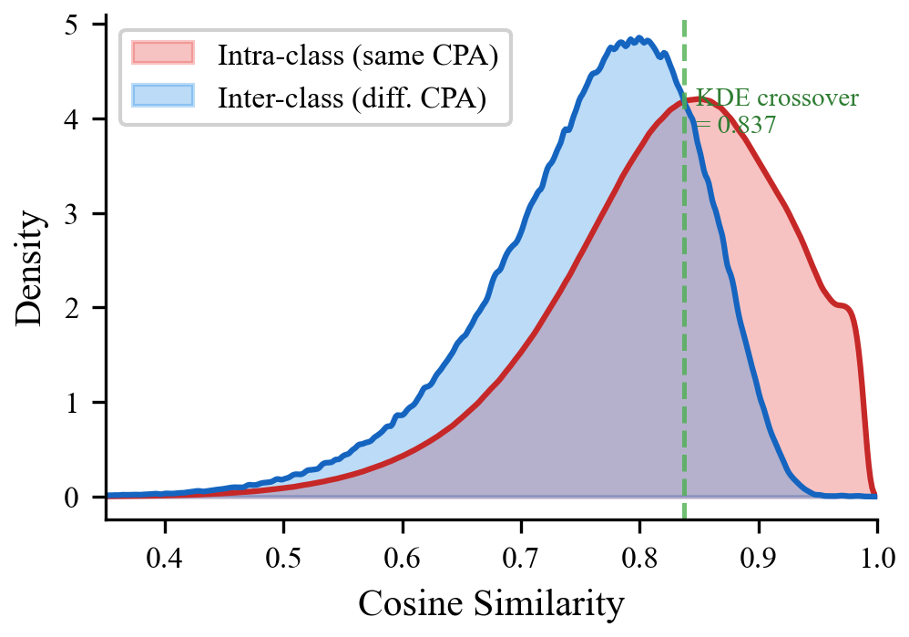
Fig. 2. Cosine similarity distributions: intra-class (same CPA) vs. inter-class (different CPAs). KDE crossover at 0.837 marks the Bayes-optimal decision boundary.
TABLE IV: Cosine Similarity Distribution Statistics
Statistic | Intra-class | Inter-class
N (pairs) | 41,352,824 | 500,000
Mean | 0.821 | 0.758
Std. Dev. | 0.098 | 0.090
Median | 0.836 | 0.774

Cohen’s d of 0.669 indicates a medium effect size, confirming that the distributional difference is not merely statistically significant but also practically meaningful.

C. Calibration Group Analysis
Fig. 3 presents the per-signature best-match cosine similarity distribution of Firm A compared to other CPAs.
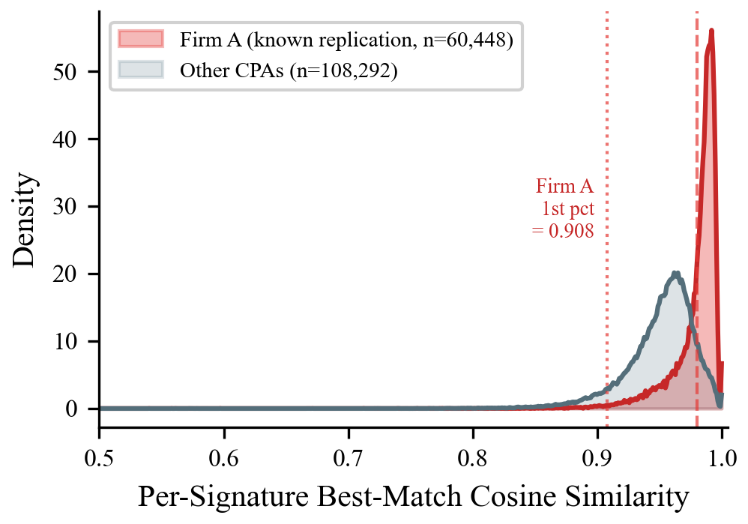
Fig. 3. Per-signature best-match cosine similarity: Firm A (known replication) vs. other CPAs. Firm A’s 1st percentile (0.908) validates threshold selection.
TABLE VI: Firm A Calibration Statistics (Per-Signature Best Match)
Statistic | Firm A | All CPAs
N (signatures) | 60,448 | 168,740
Mean | 0.980 | 0.961
Std. Dev. | 0.019 | 0.029
1st percentile | 0.908 | —
% > 0.95 | 92.5% | —
% > 0.90 | 99.3% | —

Firm A’s per-signature best-match cosine similarity (mean = 0.980, std = 0.019) is notably higher and more concentrated than the overall CPA population (mean = 0.961, std = 0.029). Critically, 99.3% of Firm A’s signatures exhibit a best-match similarity exceeding 0.90, and the 1st percentile is 0.908—establishing that any threshold below 0.91 would fail to capture even the most dissimilar replicated signatures in the calibration group.

D. Classification Results
TABLE VII: Classification Results (85,042 Documents)
Verdict | N (PDFs) | % | Description
Definite replication | 2,403 | 2.8% | Pixel-level evidence
Likely replication | 69,255 | 81.4% | Feature-level evidence
Uncertain | 12,681 | 14.9% | Between thresholds
Likely genuine | 47 | 0.1% | Below KDE crossover
Unknown | 656 | 0.8% | Unmatched CPA

The most striking finding is the discrepancy between feature-level and pixel-level evidence. Of the 71,656 documents with cosine similarity exceeding 0.95, only 3.4% (2,427) simultaneously exhibited SSIM > 0.95, and only 4.3% (3,081) had a pHash distance of 0. This gap demonstrates that the vast majority of high cosine similarity scores reflect consistent signing style rather than digital replication, vindicating the dual-method approach.
The 267 pixel-identical signatures (0.4%) constitute the strongest evidence of digital replication, as it is physically impossible for two instances of genuine handwriting to produce identical pixel arrays.

E. Ablation Study: Feature Backbone Comparison
To validate the choice of ResNet-50, we compared three pre-trained architectures (Fig. 4).
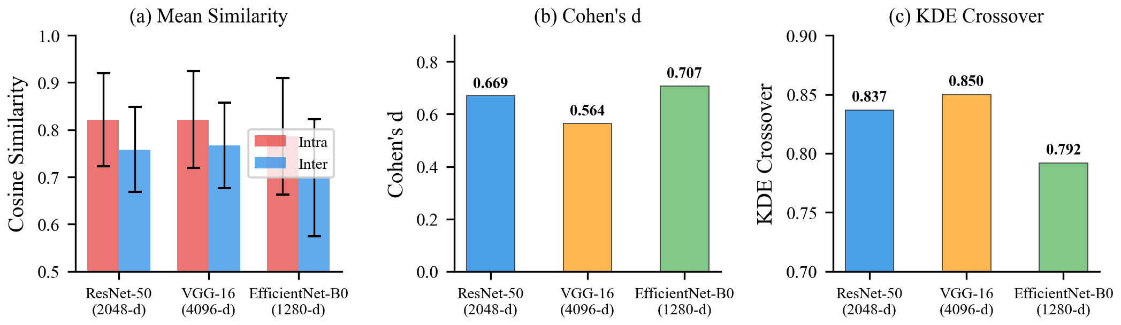
Fig. 4. Ablation study comparing three feature extraction backbones: (a) intra/inter-class mean similarity, (b) Cohen’s d, (c) KDE crossover point.
TABLE IX: Backbone Comparison
Metric | ResNet-50 | VGG-16 | EfficientNet-B0
Feature dim | 2048 | 4096 | 1280
Intra mean | 0.821 | 0.822 | 0.786
Inter mean | 0.758 | 0.767 | 0.699
Cohen’s d | 0.669 | 0.564 | 0.707
KDE crossover | 0.837 | 0.850 | 0.792
Firm A mean | 0.826 | 0.820 | 0.810
Firm A 1st pct | 0.543 | 0.520 | 0.454

EfficientNet-B0 achieves the highest Cohen’s d (0.707), but exhibits the widest distributional spread, resulting in lower per-sample classification confidence. VGG-16 performs worst despite the highest dimensionality. ResNet-50 provides the best balance: competitive Cohen’s d, tightest distributions, highest Firm A 1st percentile (0.543), and practical feature dimensionality.

V. Discussion

A. Replication Detection as a Distinct Problem
Our results highlight the importance of distinguishing signature replication detection from forgery detection. Forgery detection optimizes for inter-class discriminability—maximizing the gap between genuine and forged signatures. Replication detection requires sensitivity to the upper tail of the intra-class similarity distribution, where the boundary between consistent handwriting and digital copies becomes ambiguous. The dual-method framework addresses this ambiguity in a way that single-method approaches cannot.

B. The Style-Replication Gap
The most important empirical finding is the magnitude of the gap between style similarity and digital replication. Of documents with cosine similarity exceeding 0.95, only 3.4% exhibited pixel-level evidence of actual replication via SSIM, and only 4.3% via pHash. This implies that a naive cosine-only approach would overestimate the replication rate by approximately 25-fold. This gap likely reflects the nature of CPA signing practices: many accountants develop highly consistent signing habits, resulting in signatures that appear nearly identical at the feature level while retaining microscopic handwriting variations.

C. Value of Known-Replication Calibration
The use of Firm A as a calibration reference addresses a fundamental challenge in document forensics: the scarcity of ground truth labels. Our approach leverages domain knowledge—the established practice of digital signature replication at a specific firm—to create a naturally occurring positive control group. This calibration strategy has broader applicability: any forensic detection system can benefit from identifying subpopulations with known characteristics to anchor threshold selection.

D. Limitations
Several limitations should be acknowledged. First, comprehensive ground truth labels are not available for the full dataset. While pixel-identical cases and Firm A provide anchor points, a small-scale manual verification study would strengthen confidence in classification boundaries. Second, the ResNet-50 feature extractor was not fine-tuned on domain-specific data. Third, scanning equipment and compression algorithms may have changed over the 10-year study period. Fourth, the classification framework does not account for potential changes in signing practice over time. Finally, whether digital replication constitutes a violation of signing requirements is a legal question that our technical analysis can inform but cannot resolve.

VI. Conclusion and Future Work
We have presented an end-to-end AI pipeline for detecting digitally replicated signatures in financial audit reports at scale. Applied to 90,282 audit reports from Taiwanese publicly listed companies spanning 2013–2023, our system extracted and analyzed 182,328 CPA signatures using VLM-based page identification, YOLO-based signature detection, deep feature extraction, and dual-method similarity verification.
Our key findings are threefold. First, signature replication detection is a distinct problem from forgery detection, requiring different analytical tools. Second, combining cosine similarity with perceptual hashing is essential for distinguishing consistent handwriting style from digital duplication—a single-metric approach overestimates replication rates by approximately 25-fold. Third, a calibration methodology using a known-replication reference group provides empirical threshold validation in the absence of comprehensive ground truth.
An ablation study confirmed that ResNet-50 offers the best balance of discriminative power, classification stability, and computational efficiency among three evaluated backbones.
Future directions include domain-adapted feature extractors, temporal analysis of signing practice evolution, cross-country generalization, regulatory system integration, and small-scale ground truth validation through expert review.

References
[1] Taiwan Certified Public Accountant Act (會計師法), Art. 4; FSC Attestation Regulations (查核簽證核準準則), Art. 6.
[2] S.-H. Yen, Y.-S. Chang, and H.-L. Chen, “Does the signature of a CPA matter? Evidence from Taiwan,” Res. Account. Regul., vol. 25, no. 2, pp. 230–235, 2013.
[3] J. Bromley et al., “Signature verification using a Siamese time delay neural network,” in Proc. NeurIPS, 1993.
[4] S. Dey et al., “SigNet: Convolutional Siamese network for writer independent offline signature verification,” arXiv:1707.02131, 2017.
[5] I. Hadjadj et al., “An offline signature verification method based on a single known sample and an explainable deep learning approach,” Appl. Sci., vol. 10, no. 11, p. 3716, 2020.
[6] H. Li et al., “TransOSV: Offline signature verification with transformers,” Pattern Recognit., vol. 145, p. 109882, 2024.
[7] S. Tehsin et al., “Enhancing signature verification using triplet Siamese similarity networks in digital documents,” Mathematics, vol. 12, no. 17, p. 2757, 2024.
[8] P. Brimoh and C. C. Olisah, “Consensus-threshold criterion for offline signature verification using CNN learned representations,” arXiv:2401.03085, 2024.
[9] N. Woodruff et al., “Fully-automatic pipeline for document signature analysis to detect money laundering activities,” arXiv:2107.14091, 2021.
[10] Copy-move forgery detection in digital image forensics: A survey, Multimedia Tools Appl., 2024.
[11] S. Abramova and R. Bohme, “Detecting copy-move forgeries in scanned text documents,” in Proc. Electronic Imaging, 2016.
[12] Y. Jakhar and M. D. Borah, “Effective near-duplicate image detection using perceptual hashing and deep learning,” Inf. Process. Manage., p. 104086, 2025.
[13] E. Pizzi et al., “A self-supervised descriptor for image copy detection,” in Proc. CVPR, 2022.
[14] A survey of perceptual hashing for multimedia, ACM Trans. Multimedia Comput. Commun. Appl., vol. 21, no. 7, 2025.
[15] D. Engin et al., “Offline signature verification on real-world documents,” in Proc. CVPRW, 2020.
[16] D. Tsourounis et al., “From text to signatures: Knowledge transfer for efficient deep feature learning in offline signature verification,” Expert Syst. Appl., 2022.
[17] B. Chamakh and O. Bounouh, “A unified ResNet18-based approach for offline signature classification and verification,” Procedia Comput. Sci., vol. 270, 2025.
[18] Qwen2.5-VL Technical Report, Alibaba Group, 2025.
[19] Ultralytics, “YOLOv11 documentation,” 2024. [Online]. Available: https://docs.ultralytics.com/
[20] K. He, X. Zhang, S. Ren, and J. Sun, “Deep residual learning for image recognition,” in Proc. CVPR, 2016.
[21] J. V. Carcello and C. Li, “Costs and benefits of requiring an engagement partner signature: Recent experience in the United Kingdom,” The Accounting Review, vol. 88, no. 5, pp. 1511–1546, 2013.
[22] A. D. Blay, M. Notbohm, C. Schelleman, and A. Valencia, “Audit quality effects of an individual audit engagement partner signature mandate,” Int. J. Auditing, vol. 18, no. 3, pp. 172–192, 2014.
[23] W. Chi, H. Huang, Y. Liao, and H. Xie, “Mandatory audit partner rotation, audit quality, and market perception: Evidence from Taiwan,” Contemp. Account. Res., vol. 26, no. 2, pp. 359–391, 2009.
[24] L. G. Hafemann, R. Sabourin, and L. S. Oliveira, “Learning features for offline handwritten signature verification using deep convolutional neural networks,” Pattern Recognit., vol. 70, pp. 163–176, 2017.
[25] L. G. Hafemann, R. Sabourin, and L. S. Oliveira, “Meta-learning for fast classifier adaptation to new users of signature verification systems,” IEEE Trans. Inf. Forensics Security, vol. 15, pp. 1735–1745, 2019.
[26] E. N. Zois, D. Tsourounis, and D. Kalivas, “Similarity distance learning on SPD manifold for writer independent offline signature verification,” IEEE Trans. Inf. Forensics Security, vol. 19, pp. 1342–1356, 2024.
[27] H. Farid, “Image forgery detection,” IEEE Signal Process. Mag., vol. 26, no. 2, pp. 16–25, 2009.
[28] F. Z. Mehrjardi, A. M. Latif, M. S. Zarchi, and R. Sheikhpour, “A survey on deep learning-based image forgery detection,” Pattern Recognit., vol. 144, art. no. 109778, 2023.
[29] A. Babenko, A. Slesarev, A. Chigorin, and V. Lempitsky, “Neural codes for image retrieval,” in Proc. ECCV, 2014, pp. 584–599.
[30] J. Redmon, S. Divvala, R. Girshick, and A. Farhadi, “You only look once: Unified, real-time object detection,” in Proc. CVPR, 2016, pp. 779–788.
[31] J. Zhang, J. Huang, S. Jin, and S. Lu, “Vision-language models for vision tasks: A survey,” IEEE Trans. Pattern Anal. Mach. Intell., vol. 46, no. 8, pp. 5625–5644, 2024.
[32] Z. Wang, A. C. Bovik, H. R. Sheikh, and E. P. Simoncelli, “Image quality assessment: From error visibility to structural similarity,” IEEE Trans. Image Process., vol. 13, no. 4, pp. 600–612, 2004.
[33] B. W. Silverman, Density Estimation for Statistics and Data Analysis. London: Chapman & Hall, 1986.
[34] J. Cohen, Statistical Power Analysis for the Behavioral Sciences, 2nd ed. Hillsdale, NJ: Lawrence Erlbaum, 1988.
[35] H. B. Mann and D. R. Whitney, “On a test of whether one of two random variables is stochastically larger than the other,” Ann. Math. Statist., vol. 18, no. 1, pp. 50–60, 1947.

